**Ideation Phase**

**Brainstorm & Idea Prioritization Template**

|  |  |
| --- | --- |
| Date | 20 October 2022 |
| Team ID | PNT2022TMID52458 |
| Project Name | DemandEst-AI Powered Food Demand Forecaster. |
| Maximum Marks | 4 Marks |

**Step-1: Team Gathering, Collaboration and Select the Problem Statement**

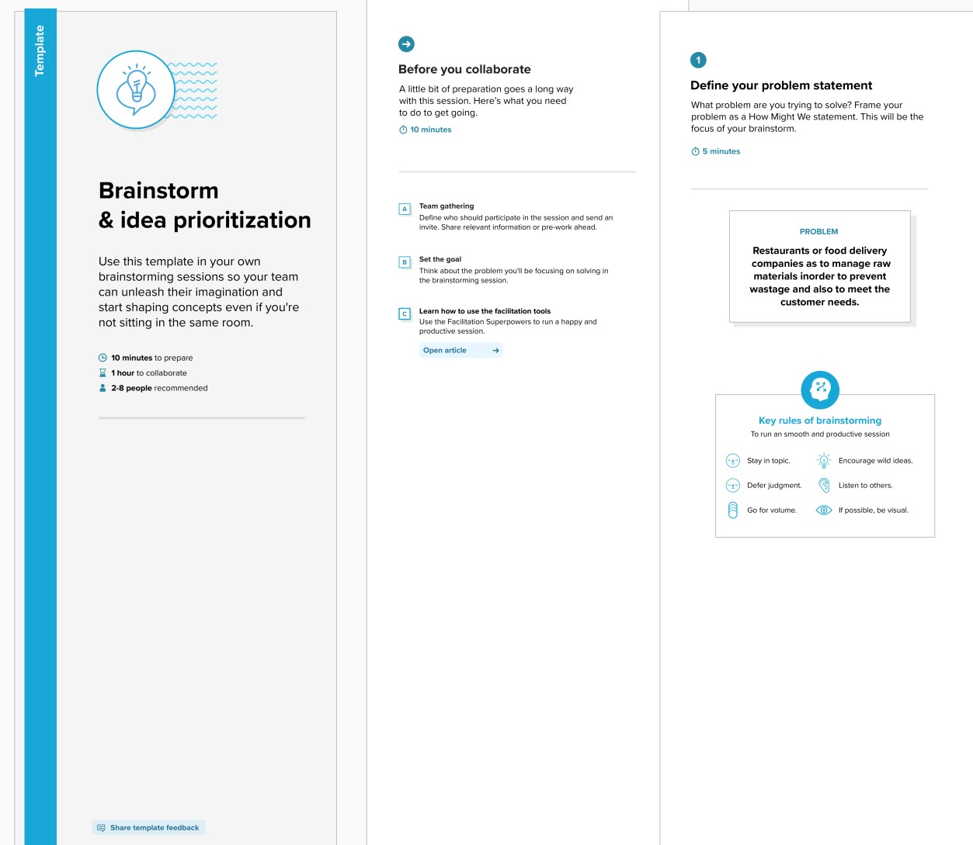

# Step-2: Brainstorm, Idea Listing and Grouping

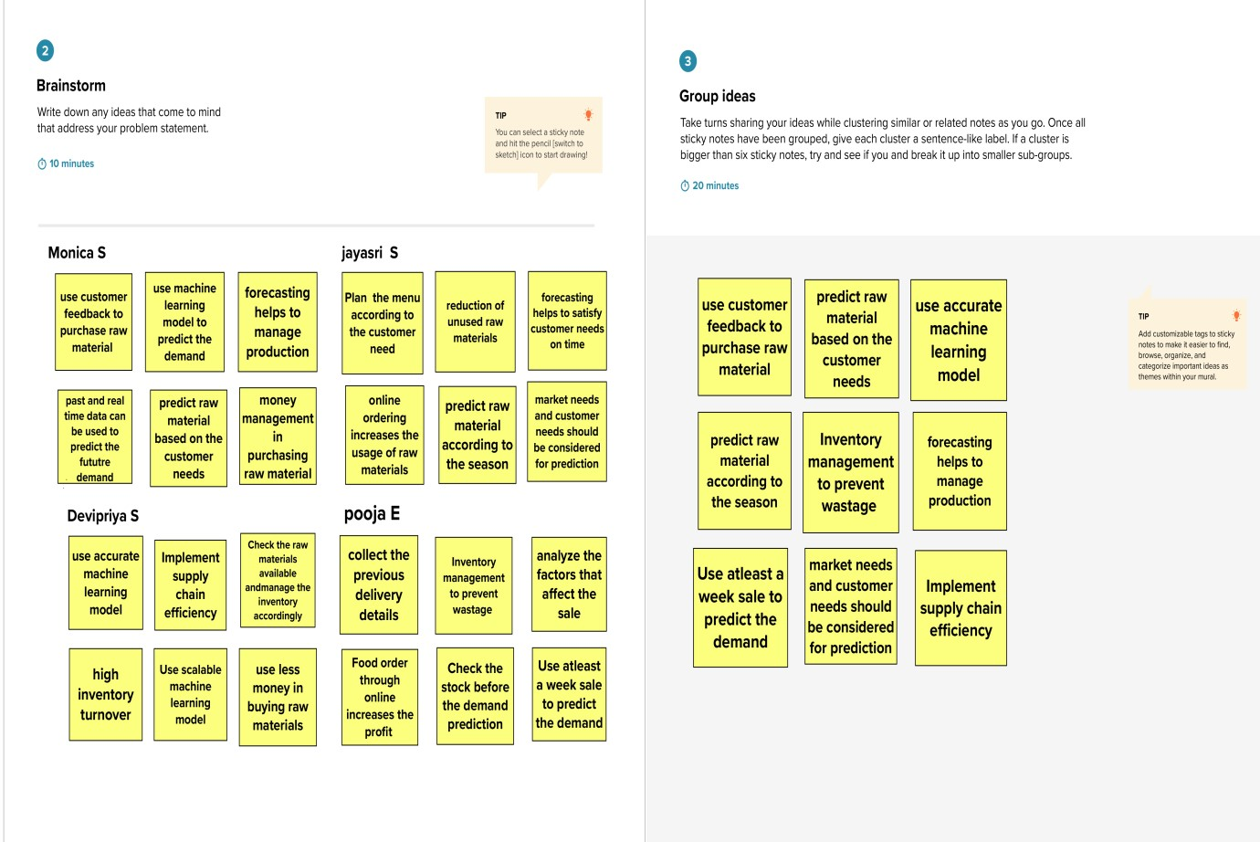

# Step-3: Idea Prioritization

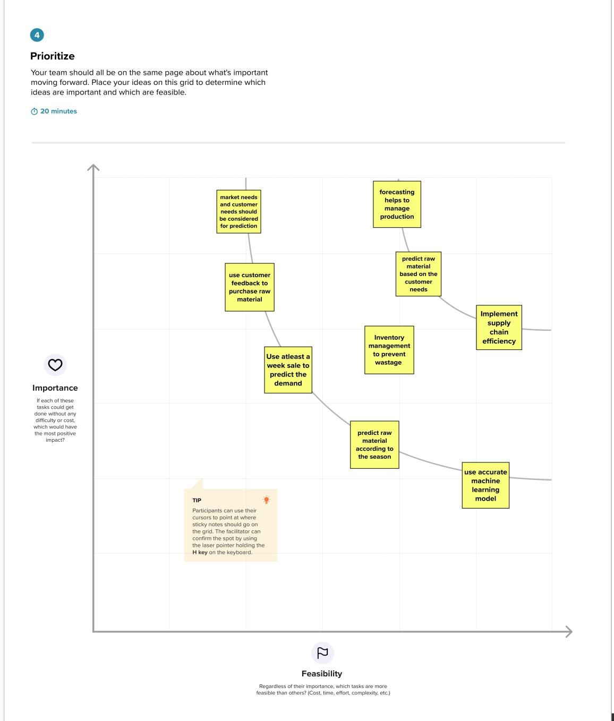

## STEP 4 :

## These are the steps involved in brainstorming and ideation phase